**EDGE Final Project**

Contents

Project Title 2

Abstract 2

Introduction 2

Types of Differential Equations 3

Applied sector of Differential Equation in Science and Engineering 3

Final Discussion 5

References 5

Conclusion 6



EDGE Final Project

3rd December, 2024 Contact: mujahidul.mi25@gmail.com

# Project Title

Investigating the application of differential equations in Science and Engineering.

# Abstract

This project explores the pivotal role of differential equations in the fields of science and engineering, emphasizing their utility in modeling, analyzing, and solving real-world problems. Differential equations serve as fundamental tools for describing dynamic systems, enabling the prediction of natural phenomena and the design of engineering solutions. The project investigates key applications across diverse disciplines, including physics, biology, chemistry, and engineering domains such as structural mechanics, fluid dynamics, and electrical circuits. Case studies will be presented to illustrate how differential equations are used to model processes like heat conduction, population dynamics, and electromagnetic wave propagation. Advanced computational techniques and numerical methods are also explored to address challenges in solving complex equations. By demonstrating the interdisciplinary significance of differential equations, this project underscores their essential contribution to scientific discovery and technological innovation.

## Introduction

Differential equations are a cornerstone of mathematical modeling, providing a powerful framework for describing how physical, chemical, and biological systems evolve over time or space. They are fundamental to understanding and predicting dynamic behavior in various fields, from the motion of celestial bodies in physics to the diffusion of heat in engineering. In this project, we delve into the diverse applications of differential equations, highlighting their significance in solving real-world problems. By bridging theoretical mathematics and practical applications, we aim to showcase how differential equations serve as indispensable tools in science and engineering. This study will also explore modern computational approaches to solving these equations, addressing complex challenges and opening new pathways for innovation.

### Types of Differential Equations

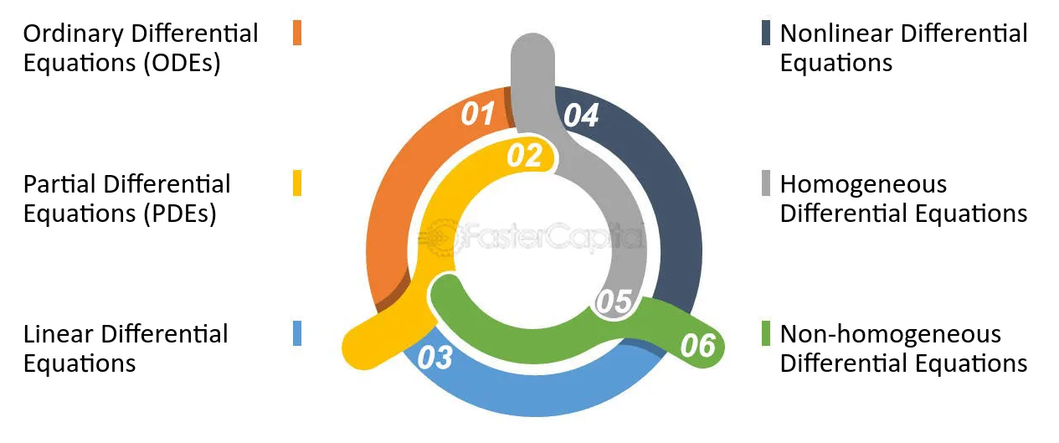

### Applied sector of Differential Equation in Science and Engineering

Differential equations are fundamental tools in science and engineering, used to model and analyze a wide range of phenomena. Here are some key applications:

In Physics:

1. Classical Mechanics: Newton's laws of motion are expressed as differential equations, describing the motion of objects under the influence of forces.

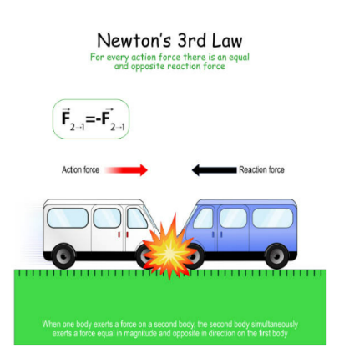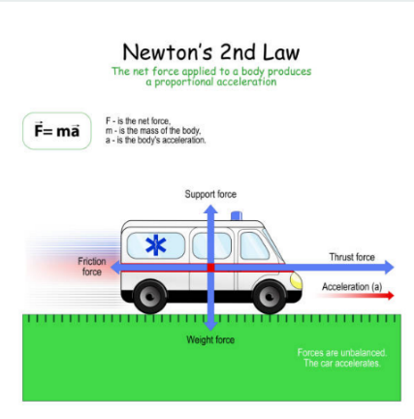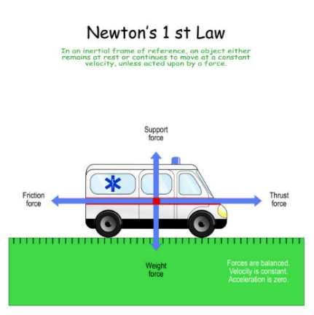

In Science:

1. Modelling Radioactive Decay:

Radioactive decay is the process by which an unstable atomic nucleus emits radiation such as an alpha particle, beta particle or gamma particle with a neutrino. This process is a good example of exponential decay.

Consider the case of $N_{A}$ decaying to $N_{B}$, $N_{A}→N_{B}$. In this case decay rate is proportional to number of atoms present $N_{A}$. Adding, a constant of proportionality or the decay constant, which is unique to every element, we get a general differential equation

$$\frac{{dN}_{A}}{dt}=-λ_{A}N_{A}$$

In the case of element $N_{A}$ decaying to $N_{B}$ decaying to $N_{C}$, $N_{A}→N_{B}→N_{C}$

$$\frac{{dN}_{B}}{dt}=-λ_{B}N_{B}+λ_{B}N_{A}$$

$$\frac{{dN}_{c}}{dt}=λ_{B}N_{B}$$

For this model, the following values were assumed:

|  |  |  |
| --- | --- | --- |
| Command | Value | Description |
| $$t_{half}A$$ | 1.1 hours | Time for half of $N_{A}$ atoms to decay. |
| $$t_{half}B$$ | 9.2 hours | Time for half of $N_{B}$ atoms to decay. |
| $${N }_{A}(0)$$ | 100 | Number of atoms of $N_{A}$ at t = 0 |
| $$N_{B}(0)$$ | 0 | Number of atoms of $N_{B}$ at t = 0 |
| $$N_{C}(0)$$ | 0 | Number of atoms of $N_{C}$ at t = 0 |
| $$t_{final}$$ | 50 hours | Time for full simulation. |

By definition, a derivative is

$$\frac{df}{dt}=\lim_{δt→0}{{\left(\frac{f\left(x+δt\right)-f(x)}{δt}\right)}^{1}}$$

Applying this to the first three differential equations we get

$$\frac{N_{C }\left(t+δt\right)-N_{C}(t)}{δt}=λ_{B}N_{B }(t)$$

After re-arranging we find,

$$N_{C}\left(t+δt\right)=λ_{C}N_{C}\left(t\right)δt+N_{C}(t)$$

It is to be noted that three different values of were considered, 1 hour, 0.5 hours and 0.25 hours and their impacts on the model were mainly in increasing the granularity of the different curves.

### Final Discussion

The key observation is that in our world there are not two but three main kinds of reality (Halmos, 1980). Mind and matter are familiar. But they do not help with our puzzle, because mathematical objects are not material, and they are not mental, in the sense of being part of anyone's private subjectivity (Kemeny, 1959). But they are not the only things that are neither mind nor matter (Hersh, 1998).

# References

Halmos, P. R. (1980). The Heart of Mathematics. *The American Mathematical Monthly*.

Hersh, R. ( 1998). What is Mathematics, Really? *Mitteilungen der Deutschen Mathematiker-Vereinigung*.

Kemeny, J. G. (1959). Mathematics without Numbers. *Daedalus 88, no. 4* .

### Conclusion

Differential equations are vital in science and engineering, serving as essential tools for modeling and solving real-world problems like population dynamics, heat transfer, and mechanical systems. They bridge theoretical science and practical applications, enabling the analysis of complex systems across disciplines. With advances in computational tools, their impact continues to grow, driving innovation in areas such as climate modeling, quantum mechanics, and modern technology. This study highlights their importance and versatility in understanding and solving dynamic challenges.